Instance initializer block

1. [Instance initializer block](https://www.javatpoint.com/instance-initializer-block)
2. [Example of Instance initializer block](https://www.javatpoint.com/instance-initializer-block#instanceinitializerex)
3. [What is invoked firstly instance initializer block or constructor?](https://www.javatpoint.com/instance-initializer-block#instanceinitializerfirstly)
4. [Rules for instance initializer block](https://www.javatpoint.com/instance-initializer-block#instanceinitializerrules)
5. [Program of instance initializer block that is invoked after super()](https://www.javatpoint.com/instance-initializer-block#instanceinitializersuper)

|  |
| --- |
| **Instance Initializer block** is used to initialize the instance data member. It run each time when object of the class is created. |
| The initialization of the instance variable can be done directly but there can be performed extra operations while initializing the instance variable in the instance initializer block. |

Que) What is the use of instance initializer block while we can directly assign a value in instance data member? For example:

1. **class** Bike{
2. **int** speed=100;
3. }

Why use instance initializer block?

|  |
| --- |
| Suppose I have to perform some operations while assigning value to instance data member e.g. a for loop to fill a complex array or error handling etc. |

Example of instance initializer block

|  |
| --- |
| Let's see the simple example of instance initializer block that performs initialization. |

1. **class** Bike7{
2. **int** speed;
4. Bike7(){System.out.println("speed is "+speed);}
6. {speed=100;}
8. **public** **static** **void** main(String args[]){
9. Bike7 b1=**new** Bike7();
10. Bike7 b2=**new** Bike7();
11. }
12. }

Output:speed is 100

speed is 100

|  |
| --- |
| There are three places in java where you can perform operations:   1. method 2. constructor 3. block |

What is invoked first, instance initializer block or constructor?

1. **class** Bike8{
2. **int** speed;
4. Bike8(){System.out.println("constructor is invoked");}
6. {System.out.println("instance initializer block invoked");}
8. **public** **static** **void** main(String args[]){
9. Bike8 b1=**new** Bike8();
10. Bike8 b2=**new** Bike8();
11. }
12. }

[**Test it Now**](https://www.javatpoint.com/opr/test.jsp?filename=Bike8)

Output:instance initializer block invoked

constructor is invoked

instance initializer block invoked

constructor is invoked

|  |
| --- |
| In the above example, it seems that instance initializer block is firstly invoked but NO. Instance intializer block is invoked at the time of object creation. The java compiler copies the instance initializer block in the constructor after the first statement super(). So firstly, constructor is invoked. Let's understand it by the figure given below: |

Note: The java compiler copies the code of instance initializer block in every constructor.

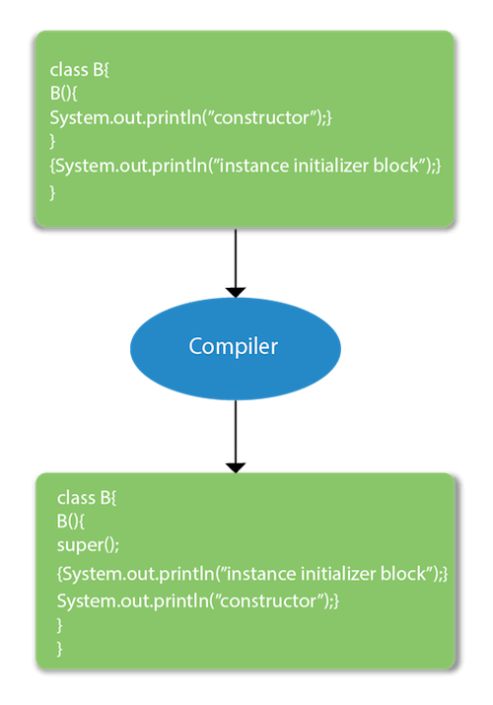

Rules for instance initializer block :

|  |
| --- |
| There are mainly three rules for the instance initializer block. They are as follows: |

1. The instance initializer block is created when instance of the class is created.
2. The instance initializer block is invoked after the parent class constructor is invoked (i.e. after super() constructor call).
3. The instance initializer block comes in the order in which they appear.

Program of instance initializer block that is invoked after super()

1. **class** A{
2. A(){
3. System.out.println("parent class constructor invoked");
4. }
5. }
6. **class** B2 **extends** A{
7. B2(){
8. **super**();
9. System.out.println("child class constructor invoked");
10. }
12. {System.out.println("instance initializer block is invoked");}
14. **public** **static** **void** main(String args[]){
15. B2 b=**new** B2();
16. }
17. }

[**Test it Now**](https://www.javatpoint.com/opr/test.jsp?filename=B2)

Output:parent class constructor invoked

instance initializer block is invoked

child class constructor invoked

Another example of instance block

1. **class** A{
2. A(){
3. System.out.println("parent class constructor invoked");
4. }
5. }
7. **class** B3 **extends** A{
8. B3(){
9. **super**();
10. System.out.println("child class constructor invoked");
11. }
13. B3(**int** a){
14. **super**();
15. System.out.println("child class constructor invoked "+a);
16. }
18. {System.out.println("instance initializer block is invoked");}
20. **public** **static** **void** main(String args[]){
21. B3 b1=**new** B3();
22. B3 b2=**new** B3(10);
23. }
24. }

parent class constructor invoked

instance initializer block is invoked

child class constructor invoked

parent class constructor invoked

instance initializer block is invoked

child class constructor invoked 10